1. **ReactJS-HOL**

**CODE:**

**App.js**  
import React from 'react';

function App() {

return (

<div>

<h1>Welcome to the first session of React</h1>

</div>

);

}

export default App;

**OUTPUT:**

1. **ReactJs_HOL**

**CODE:**  
**App.js:**

import React from 'react';

import Home from './Components/Home';

import About from './Components/About';

import Contact from './Components/Contact';

function App() {

  return (

    <div className="App">

      <Home />

      <About />

      <Contact />

    </div>

  );

}

export default App;

**About.js**

import React, { Component } from 'react';

class About extends Component {

  render() {

    return (

      <div>

        <h2>Welcome to the About page of Student Management Portal</h2>

      </div>

    );

  }

}

export default About;

**Contact.js**

import React, { Component } from 'react';

class Contact extends Component {

  render() {

    return (

      <div>

        <h2>Welcome to the Contact page of Student Management Portal</h2>

      </div>

    );

  }

}

export default Contact;

**Home.js**

import React, { Component } from 'react';

class Home extends Component {

  render() {

    return (

      <div>

        <h2>Welcome to the Home page of Student Management Portal</h2>

      </div>

    );

  }

}

export default Home;

**OUTPUT:**

1. **ReactJS_HOL**

**CODE:**

**App.js**

import React from 'react';

import './App.css';

import CalculateScore from './Components/CalculateScore';

function App() {

  return (

    <div className="App">

      <h1>Student Management Portal</h1>

      <CalculateScore name="Alice" school="Greenwood High" total={480} goal={6} />

    </div>

  );

}

export default App;

**Mystyle.css**

.score-card {

  border: 2px solid #007BFF;

  padding: 20px;

  margin: 20px;

  border-radius: 10px;

  width: 350px;

  font-family: Arial, sans-serif;

  background-color: #f0f8ff;

  box-shadow: 2px 2px 10px rgba(0,0,0,0.1);

}

.score-card h2 {

  color: #007BFF;

}

.score-card p {

  margin: 5px 0;

  font-size: 16px;

}

**CalculateScore.js**

import React from 'react';

import '../Stylesheets/mystyle.css';

function CalculateScore(props) {

  const average = props.total / props.goal;

  return (

    <div className="score-card">

      <h2>Student Score Summary</h2>

      <p><strong>Name:</strong> {props.name}</p>

      <p><strong>School:</strong> {props.school}</p>

      <p><strong>Total Score:</strong> {props.total}</p>

      <p><strong>Number of Subjects:</strong> {props.goal}</p>

      <p><strong>Average Score:</strong> {average.toFixed(2)}</p>

    </div>

  );

}

export default CalculateScore;

**OUTPUT:**

1. **ReactJS_HOL**

**CODE:**

**App.js**

import React from 'react';

import './App.css';

import Posts from './Posts';

function App() {

  return (

    <div className="App">

      <Posts />

    </div>

  );

}

export default App;

**Post.js**

class Post {

  constructor(userId, id, title, body) {

    this.userId = userId;

    this.id = id;

    this.title = title;

    this.body = body;

  }

}

export default Post;

**Posts.js**

import React, { Component } from 'react';

import Post from './Post';

class Posts extends Component {

  constructor(props) {

    super(props);

    this.state = {

      posts: [],

      hasError: false

    };

  }

  loadPosts = async () => {

    try {

      const response = await fetch('https://jsonplaceholder.typicode.com/posts');

      const data = await response.json();

      const formattedPosts = data.map(p => new Post(p.userId, p.id, p.title, p.body));

      this.setState({ posts: formattedPosts });

    } catch (error) {

      this.setState({ hasError: true });

      console.error("Failed to fetch posts", error);

    }

  };

  componentDidMount() {

    this.loadPosts();

  }

  componentDidCatch(error, info) {

    alert("An error occurred: " + error);

    console.log("Error details:", info);

  }

  render() {

    if (this.state.hasError) {

      return <h2>Error loading posts.</h2>;

    }

    return (

      <div>

        <h1>Blog Posts</h1>

        {this.state.posts.map(post => (

          <div key={post.id} style={{ borderBottom: "1px solid gray", marginBottom: "10px" }}>

            <h3>{post.title}</h3>

            <p>{post.body}</p>

          </div>

        ))}

      </div>

    );

  }

}

export default Posts;

**OUTPUT:**

**5.ReactJS_HOL**

**App.css**

.App {

  text-align: center;

}

.App-logo {

  height: 40vmin;

  pointer-events: none;

}

@media (prefers-reduced-motion: no-preference) {

  .App-logo {

    animation: App-logo-spin infinite 20s linear;

  }

}

.App-header {

  background-color: #282c34;

  min-height: 100vh;

  display: flex;

  flex-direction: column;

  align-items: center;

  justify-content: center;

  font-size: calc(10px + 2vmin);

  color: white;

}

.App-link {

  color: #61dafb;

}

@keyframes App-logo-spin {

  from {

    transform: rotate(0deg);

  }

  to {

    transform: rotate(360deg);

  }

}  
  
**App.js**

import logo from './logo.svg';

import './App.css';

import { CohortsData} from './Cohort'

import CohortDetails from './CohortDetails';

function App() {

return (

<div>

<h1>Cohorts Details</h1>

{CohortsData.map(cohort => <CohortDetails cohort={cohort}/>)}

</div>

);

}

export default App;

**App.test.js**

import { render, screen } from '@testing-library/react';

import App from './App';

test('renders learn react link', () => {

render(<App />);

const linkElement = screen.getByText(/learn react/i);

expect(linkElement).toBeInTheDocument();

});

**Cohort.js**

class Cohort {

constructor(cohortCode,

startDate,

technology,

trainerName,

coachName,

currentStatus) {

this.cohortCode = cohortCode;

this.coachName = coachName;

this.trainerName = trainerName;

this.technology = technology;

this.startDate = startDate;

this.currentStatus = currentStatus;

}

}

const CohortsData =[

new Cohort('INTADMDF10','22-Feb-2022', '.NET FSD', 'Jojo Jose','Aathma', 'Scheduled'),

new Cohort('ADM21JF014','10-Sep-2021', 'Java FSD', 'Elisa Smith','Apoorv', 'Ongoing'),

new Cohort('CDBJF21025','24-Dec-2021', 'Java FSD', 'John Doe','Aathma', 'Ongoing'),

new Cohort('INTADMJF12','22-Feb-2022', 'Java FSD', 'To Be Assigned','Ibrahim', 'Scheduled'),

new Cohort('CDE22JF011','24-Dec-2021', 'Java FSD', 'Emma Swan','Apoorv', 'Ongoing'),

new Cohort('INTADMDF09','22-Feb-2022', 'Dataware Housing', 'Babjee Rao','Aathma', 'Scheduled'),

new Cohort('ADM22DF001','10-Sep-2021', '.NET FSD', 'Marie Curie','Ibrahim', 'Ongoing'),

];

export {Cohort, CohortsData};

**CohortDetails.js**

import styles from './CohortDetails.module.css';

import React from 'react';

function CohortDetail({ cohort }) {

const headingStyle = {

color: cohort.currentStatus.toLowerCase() === 'ongoing' ? 'green' : 'blue',

};

return (

<div className={styles.box}>

<h3 style={headingStyle}>

{cohort.cohortCode} - {cohort.technology}

</h3>

<dl>

<dt>Started On</dt>

<dd>{cohort.startDate}</dd>

<dt>Current Status</dt>

<dd>{cohort.currentStatus}</dd>

<dt>Coach</dt>

<dd>{cohort.coachName}</dd>

<dt>Trainer</dt>

<dd>{cohort.trainerName}</dd>

</dl>

</div>

);

}

export default CohortDetail;

**CohortDetails.module.css**

.box {

width: 300px;

display: inline-block;

margin: 10px;

padding: 10px 20px;

border: 1px solid black;

border-radius: 10px;

}

dt {

font-weight: 500;

}

**Output:**

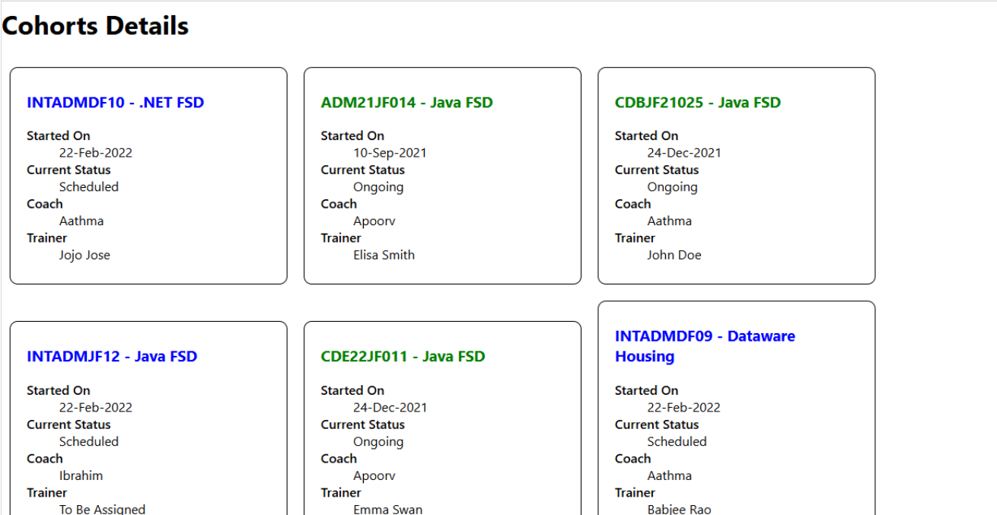

**index.css**

body {

margin: 0;

font-family: -apple-system, BlinkMacSystemFont, 'Segoe UI', 'Roboto', 'Oxygen',

'Ubuntu', 'Cantarell', 'Fira Sans', 'Droid Sans', 'Helvetica Neue',

sans-serif;

-webkit-font-smoothing: antialiased;

-moz-osx-font-smoothing: grayscale;

}

code {

font-family: source-code-pro, Menlo, Monaco, Consolas, 'Courier New',

monospace;

}

**index.js**

import React from 'react';

import ReactDOM from 'react-dom';

import './index.css';

import App from './App';

import reportWebVitals from './reportWebVitals';

ReactDOM.render(

<React.StrictMode>

<App />

</React.StrictMode>,

document.getElementById('root')

);

reportWebVitals();

**logo.svg**



**package-lock.json**

{

"name": "cohorttracker",

"lockfileVersion": 3,

"requires": true,

"packages": {}

}

**reportWebVitals.js**

const reportWebVitals = onPerfEntry => {

if (onPerfEntry && onPerfEntry instanceof Function) {

import('web-vitals').then(({ getCLS, getFID, getFCP, getLCP, getTTFB }) => {

getCLS(onPerfEntry);

getFID(onPerfEntry);

getFCP(onPerfEntry);

getLCP(onPerfEntry);

getTTFB(onPerfEntry);

});

}

};

export default reportWebVitals;

**setupTests.js**

// jest-dom adds custom jest matchers for asserting on DOM nodes.

// allows you to do things like:

// expect(element).toHaveTextContent(/react/i)

// learn more: https://github.com/testing-library/jest-dom

import '@testing-library/jest-dom';